|  |
| --- |
| Heuristic Evaluation |
| *User Interfaces* |
| Óscar Seguro Alonso -  Silvina Caíno Lores - 100303556  Ramses J Salas Machado - 100292149 |

# INDEX

SCENARIO 1

CONCLUSION 5

# SCENARIO

A user wants to buy brown cupcake cups in amazon and he will use the service for the first time.

Start page

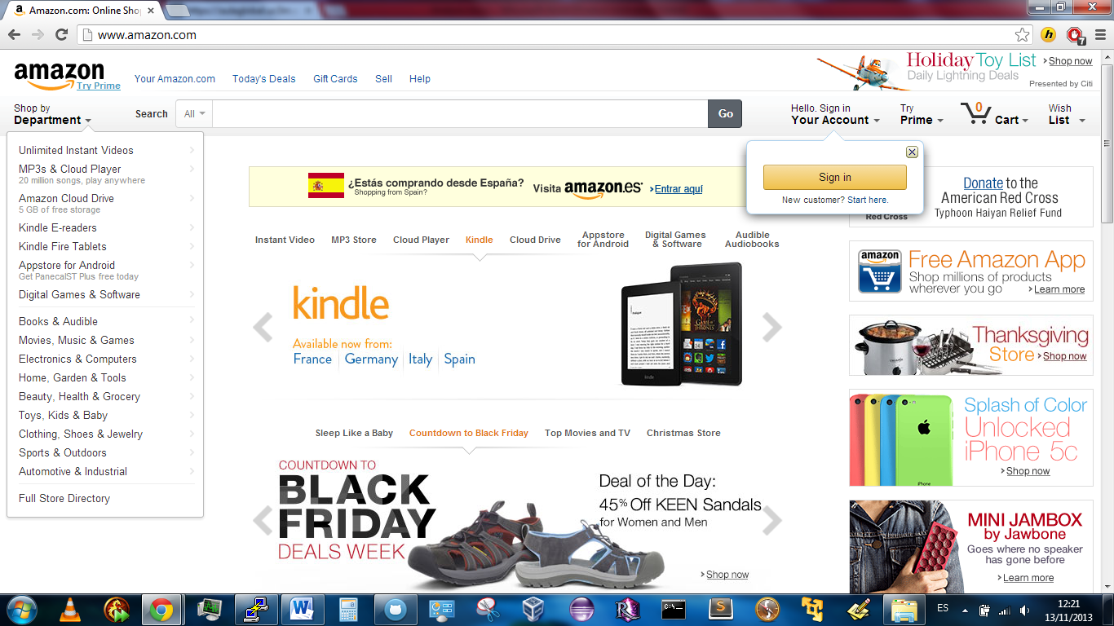

The user proceeds to perform the search using the “search bar” typing “brown cupcake cups” and he appreciate how the system guides him in order to prevent errors. Even when a clear “search bar” exist, he notices that the page is saturated with advertising and text.

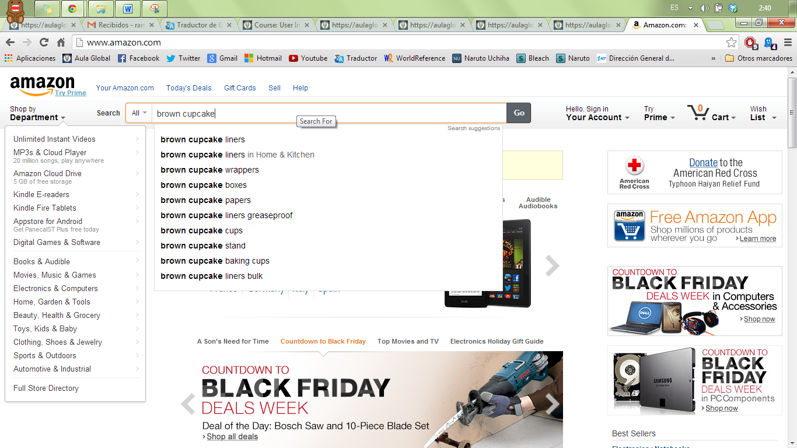

In the other hand the left navigation is populated unnecessary content, removing it could result in an improvement making the navigation panel clearer and helpful.

Search results

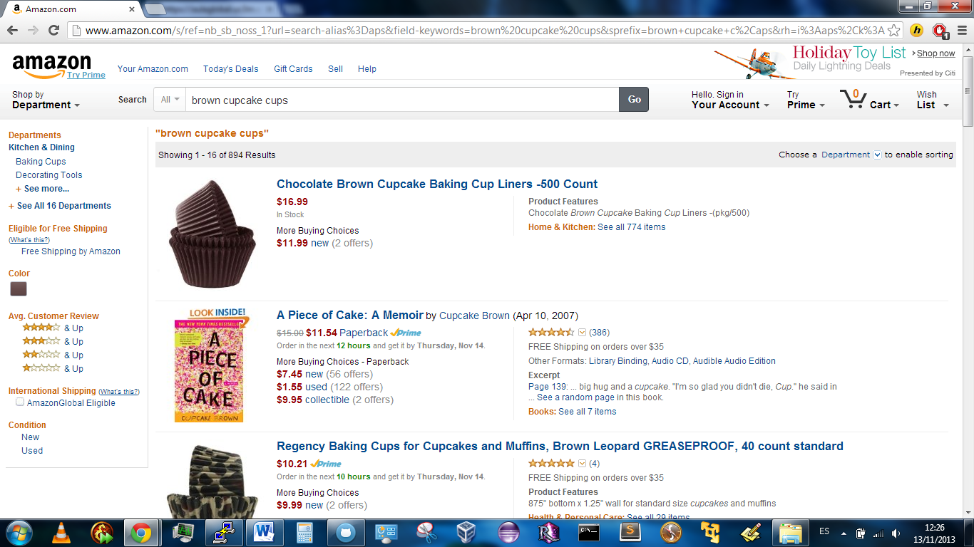

Product detail

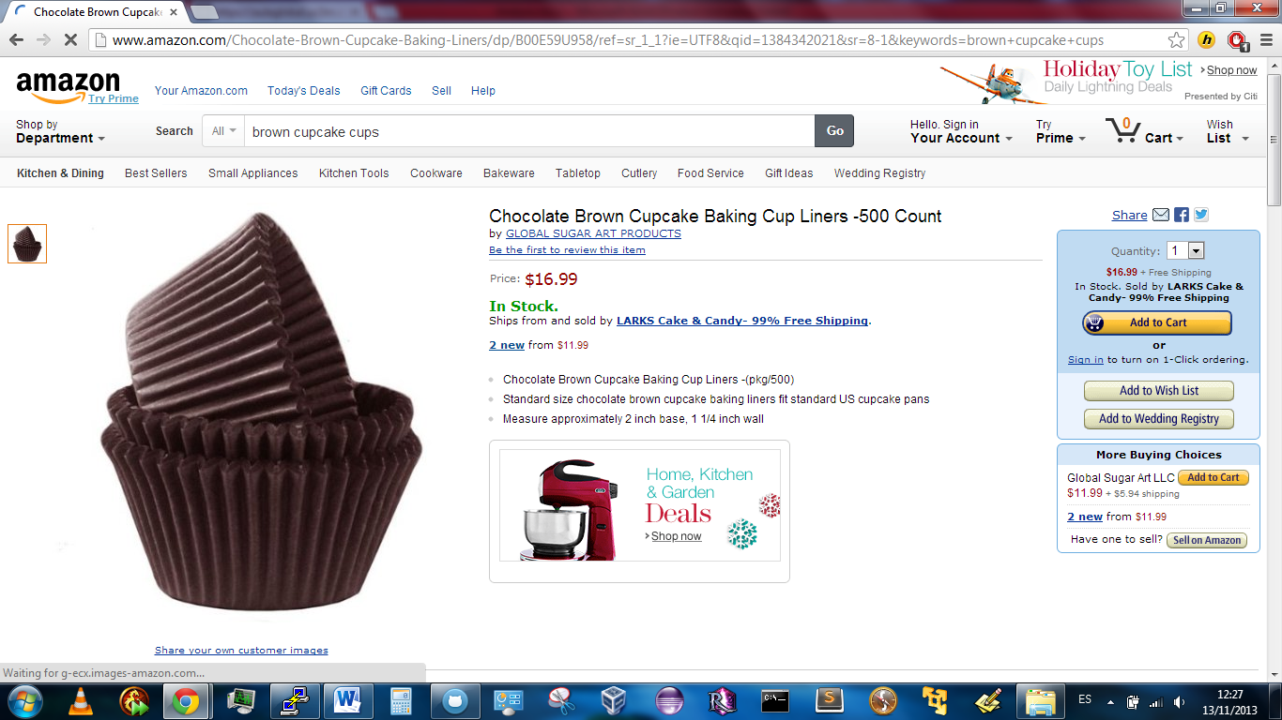

Cart addition

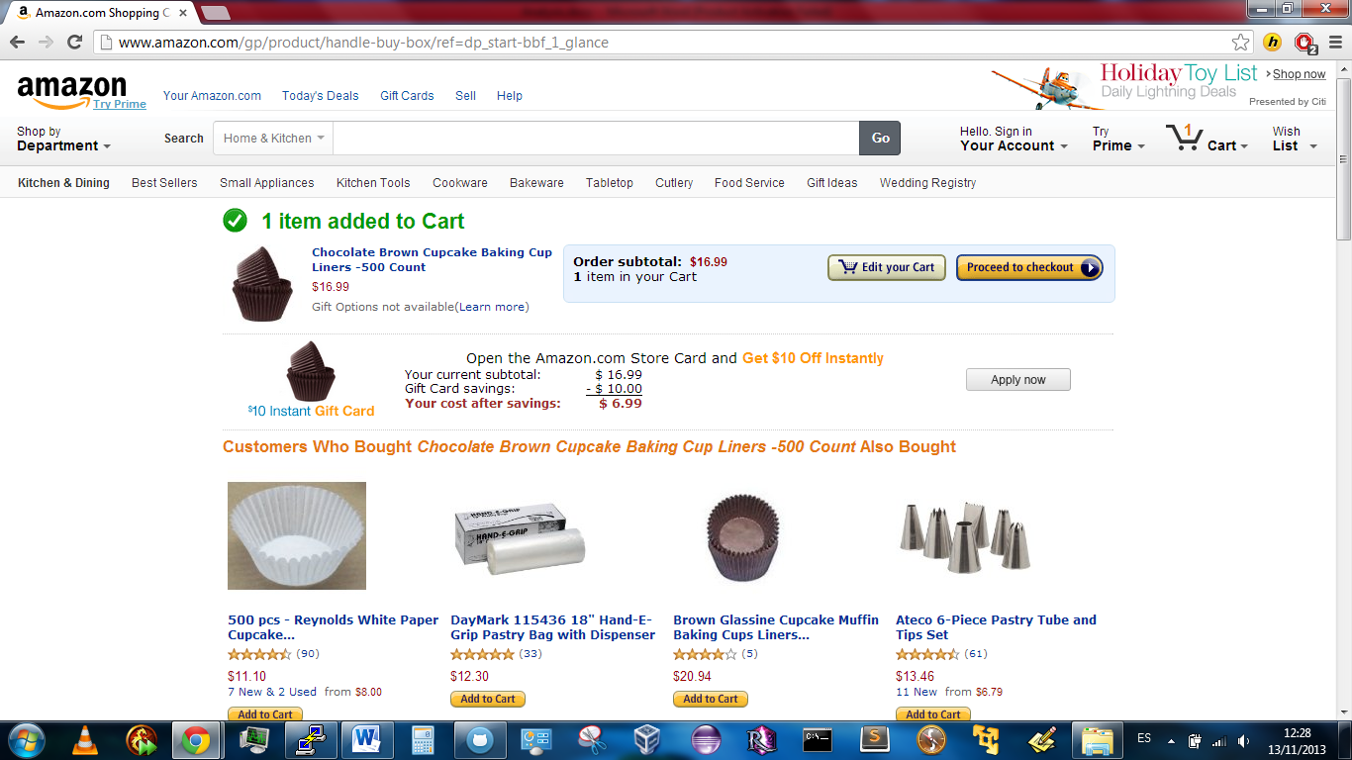

Checkout 🡪 forces registering

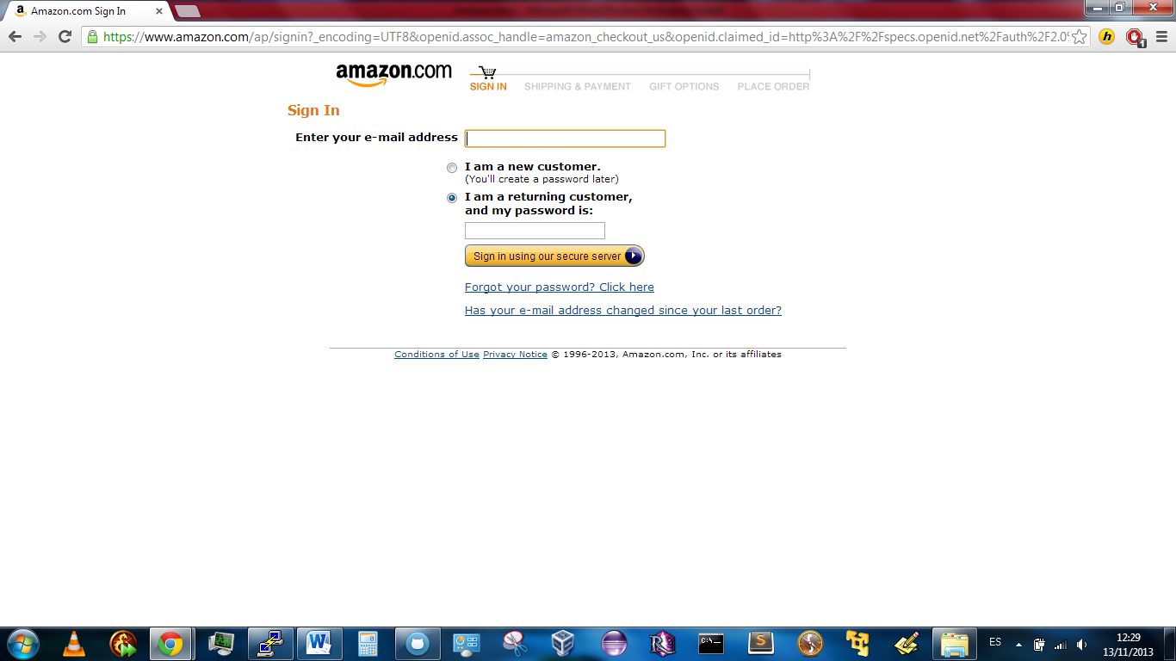

Registering

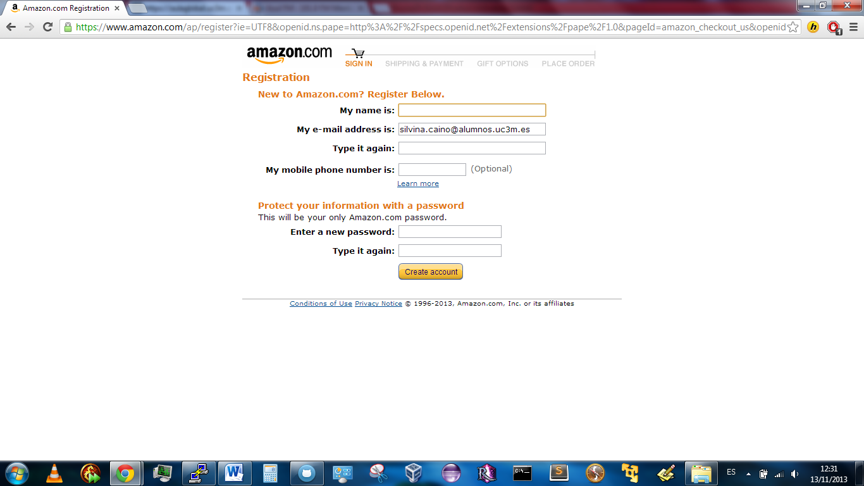

Amazon then requires the user to provide details about the shipping address to which the product will be shipped. The user is required to fulfill a form.

This form is quite simple and clear. However, maybe some users might not understand what information they are being asked for. Specially, form fields “Address Line 1” and “Address line 2” are not self-explanatory, and a message explaining what information is expected in those fields could be an useful improvement.

A positive aspect of the chosen interface is the top bar, which shows in an intuitive and visual format the step of the registration process in which the user currently is.

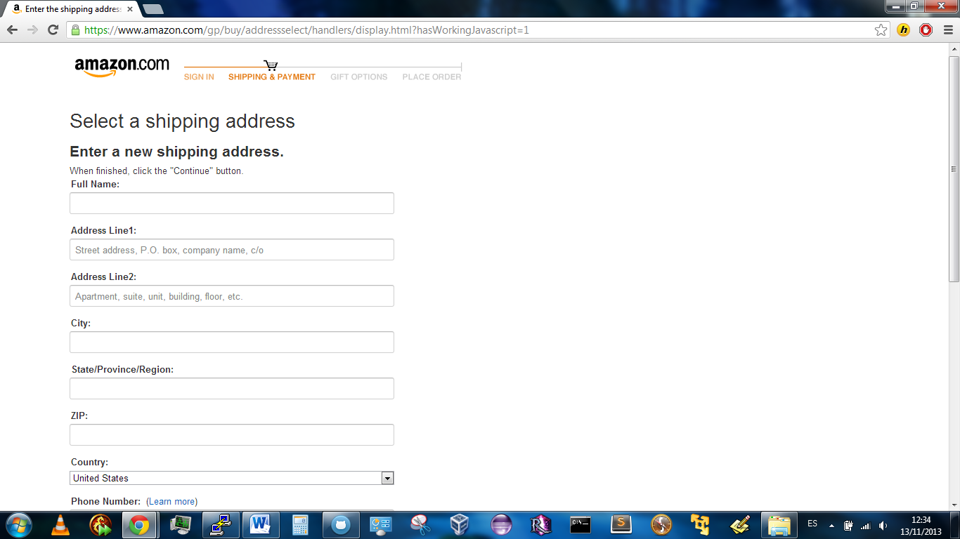

The user is given a choice between several shipping speeds, with different prices. The user can choose between them via some radio buttons. Also, while doing this, Amazon shows the summary of the purchase in the left side of the screen: name of the product, shipping company and seller, price and shipping address. The user is given the choice of learning something more about the seller through a “learn more” link, too.

An improvement could be a clearer display of this information, as there is a lot of information provided to the user in a relatively small space. For example, a list with titles (“seller: <the seller>; shipping company: <the company>; product: <the product>, etc) would be very clear and intuitive.

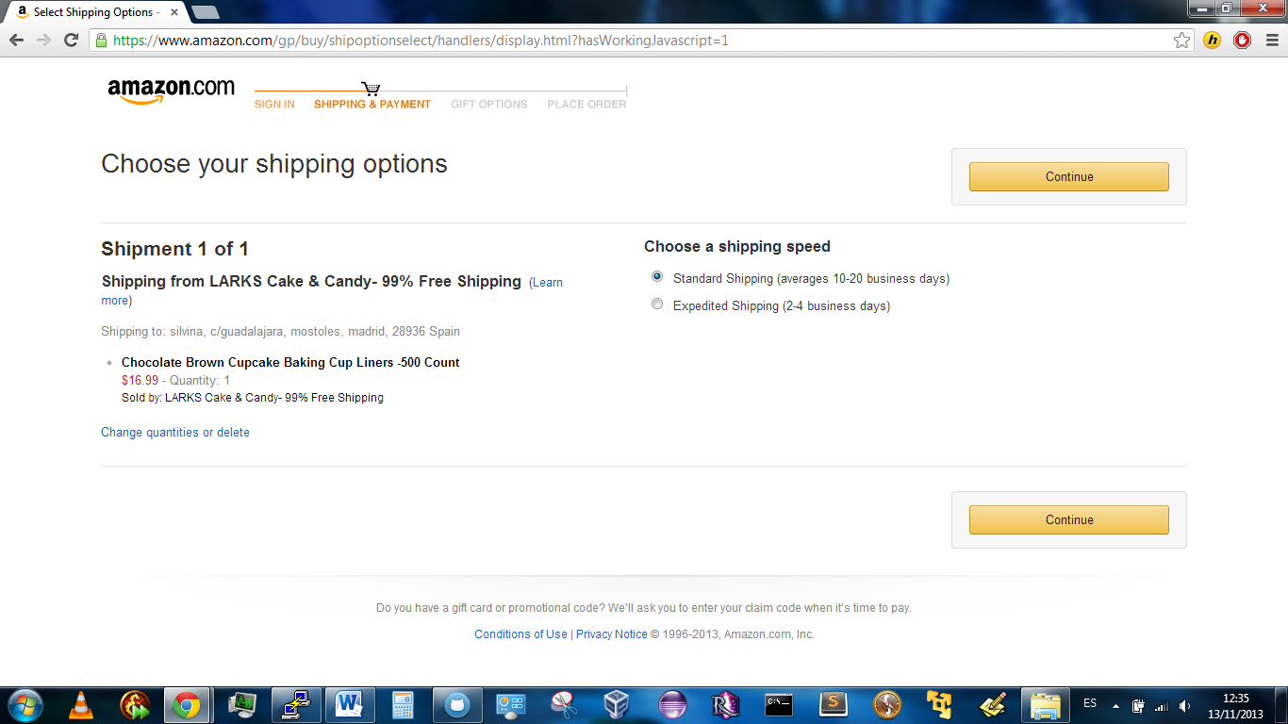

The buying process continues through a confirmation of successful purchase. However, that would mean to actually buy the product. As we are not going to buy it in real life, we are not able to analyze that last interface. However, we think the analysis of the rest of the process is more than enough to be able to do a complete Heuristic Evaluation.

# CONCLUSION